Data Technician
Week 2 Workbook
Power BI

Name: Riya Mahajan
Course Date: 21/09/2026
Table of contents
Day 3: Task 1 11
Day 3: Task 2 12
Day 3: Task 3 (Optional) 13
Day 4: Task 1 14
Day 4: Task 2 15
Day 4: Task 3 16
Course Notes 17
Additional Resources to learn and Practice 18

Day 3: Task 1
Please complete Get data in Power BI on Skillable. Once complete, paste a print screen below and in the collaboration board.

- Visit https://leeptalent.learnondemand.net/
- Sing into your profile
- Go to PL-300T00-A Design and Manage Analytics Solutions Using Power BI
- Launch and complete Lab 1: Get data in Power BI

Paste your completed lab here | 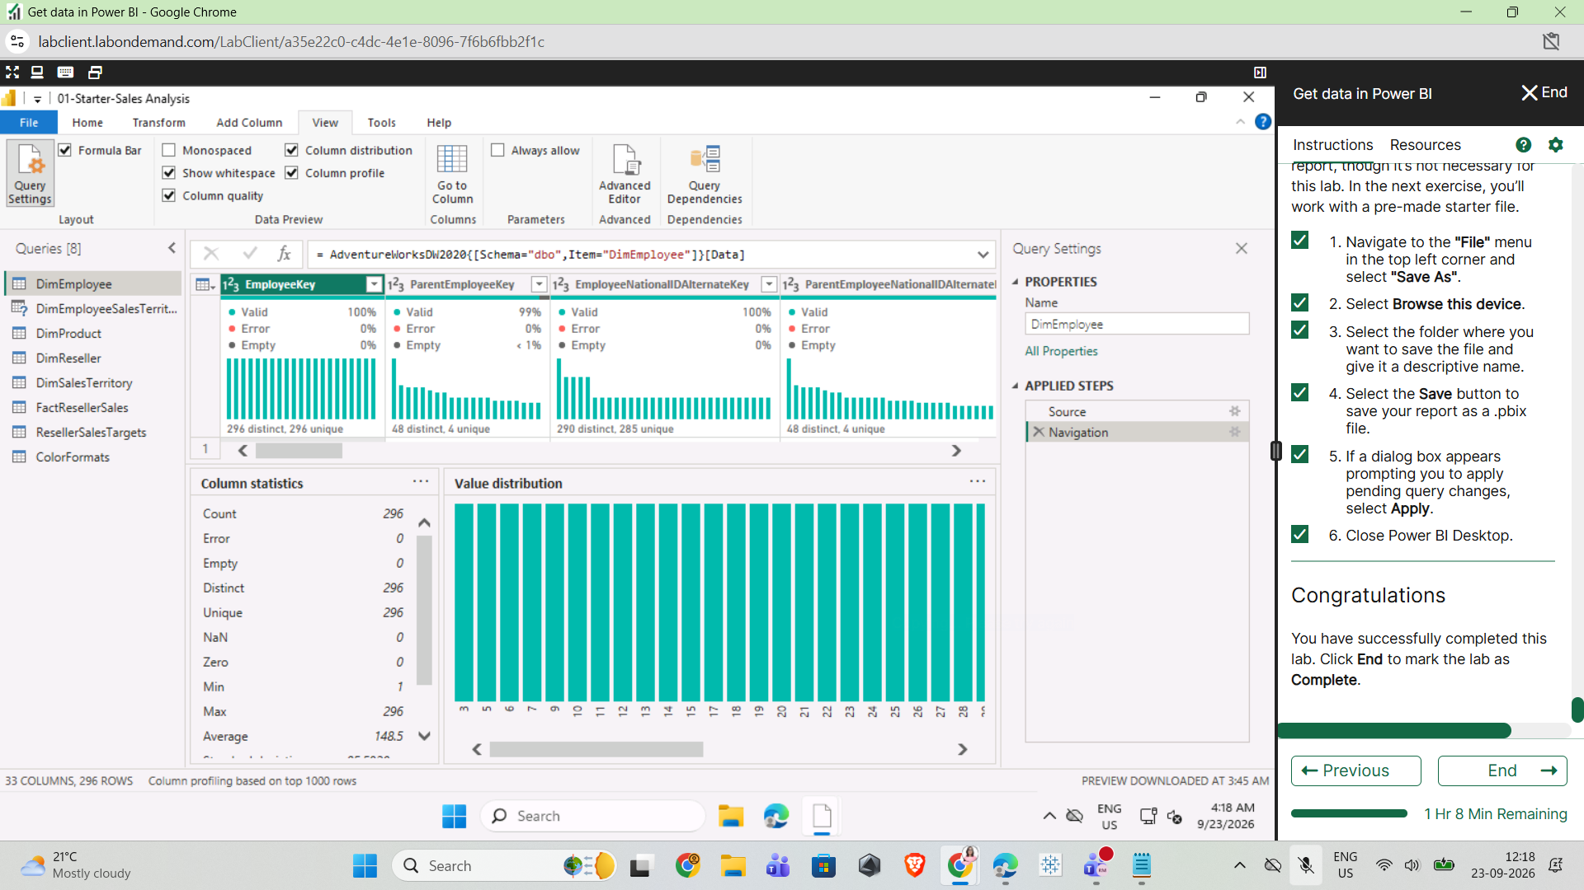

Day 3: Task 2
Please complete PL-300T00-A-Lab-02-LA] Clean, transform, and load data in Power BI on Skillable. Once complete, paste a print screen below and in the collaboration board.

- Visit https://leeptalent.learnondemand.net/
- Sing into your profile
- Go to PL-300T00-A Design and Manage Analytics Solutions Using Power BI
- Launch and complete Lab 2: Clean, transform, and load data in Power BI

Paste your completed lab here | 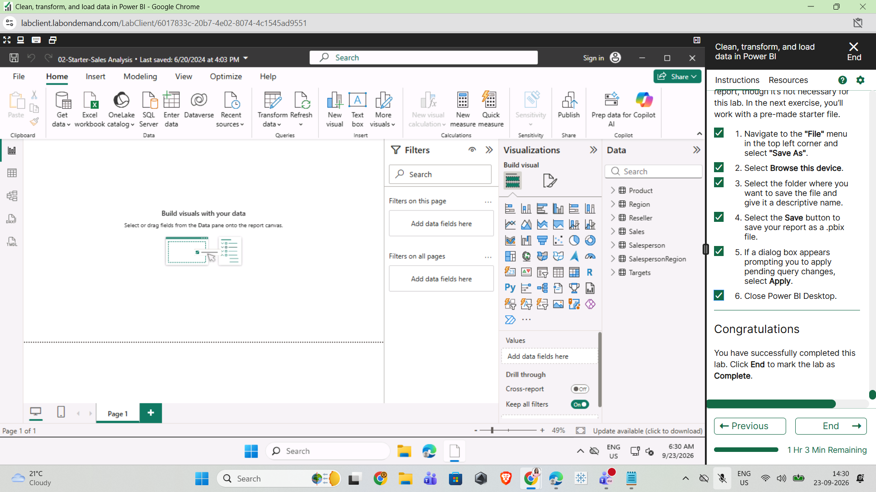  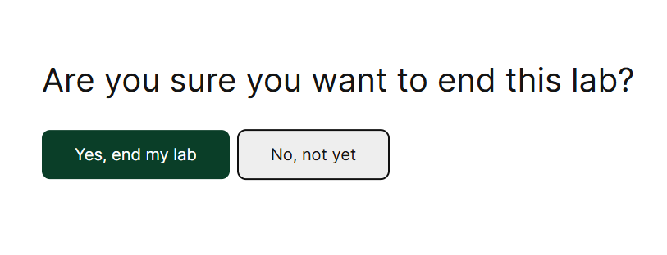

Day 3: Task 3 (Optional)

Explore Power BI course on DataCamp if you finish Day 3 Task 2 early. Introduction to Power BI

Paste your completed XP here | 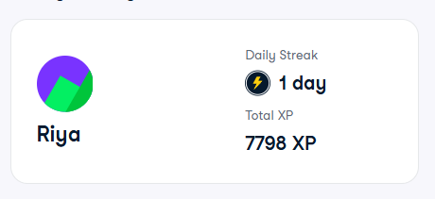  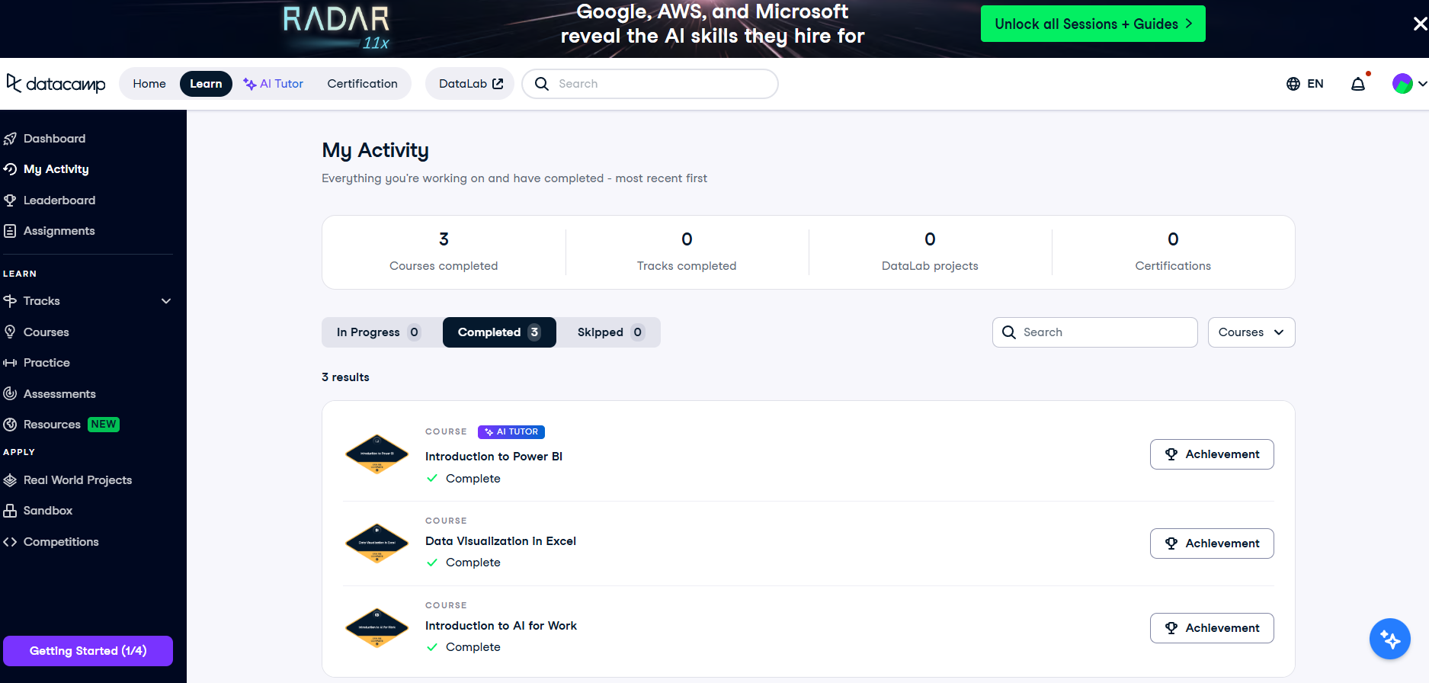

Day 4: Task 1
Please complete Design Power BI reports on Skillable. Once complete, paste a print screen below and in the collaboration board.

- Visit https://leeptalent.learnondemand.net/
- Sing into your profile
- Go to PL-300T00-A Design and Manage Analytics Solutions Using Power BI
- Launch and complete Lab 8: Design Power BI reports.

Paste your completed lab here | 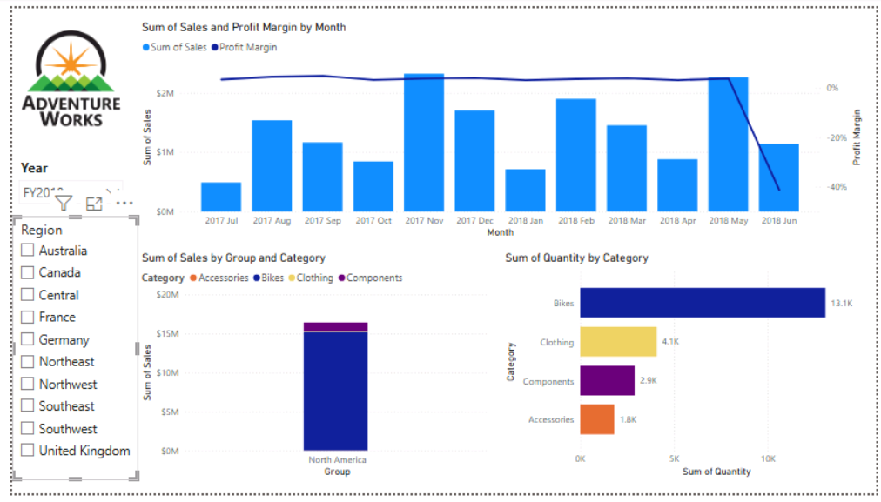  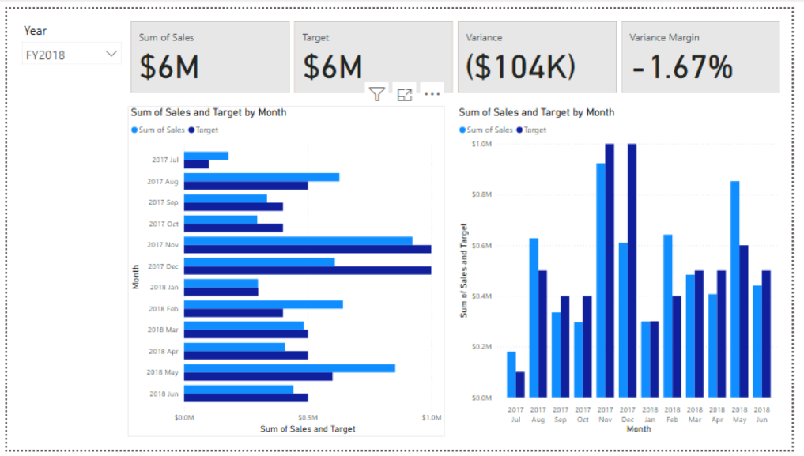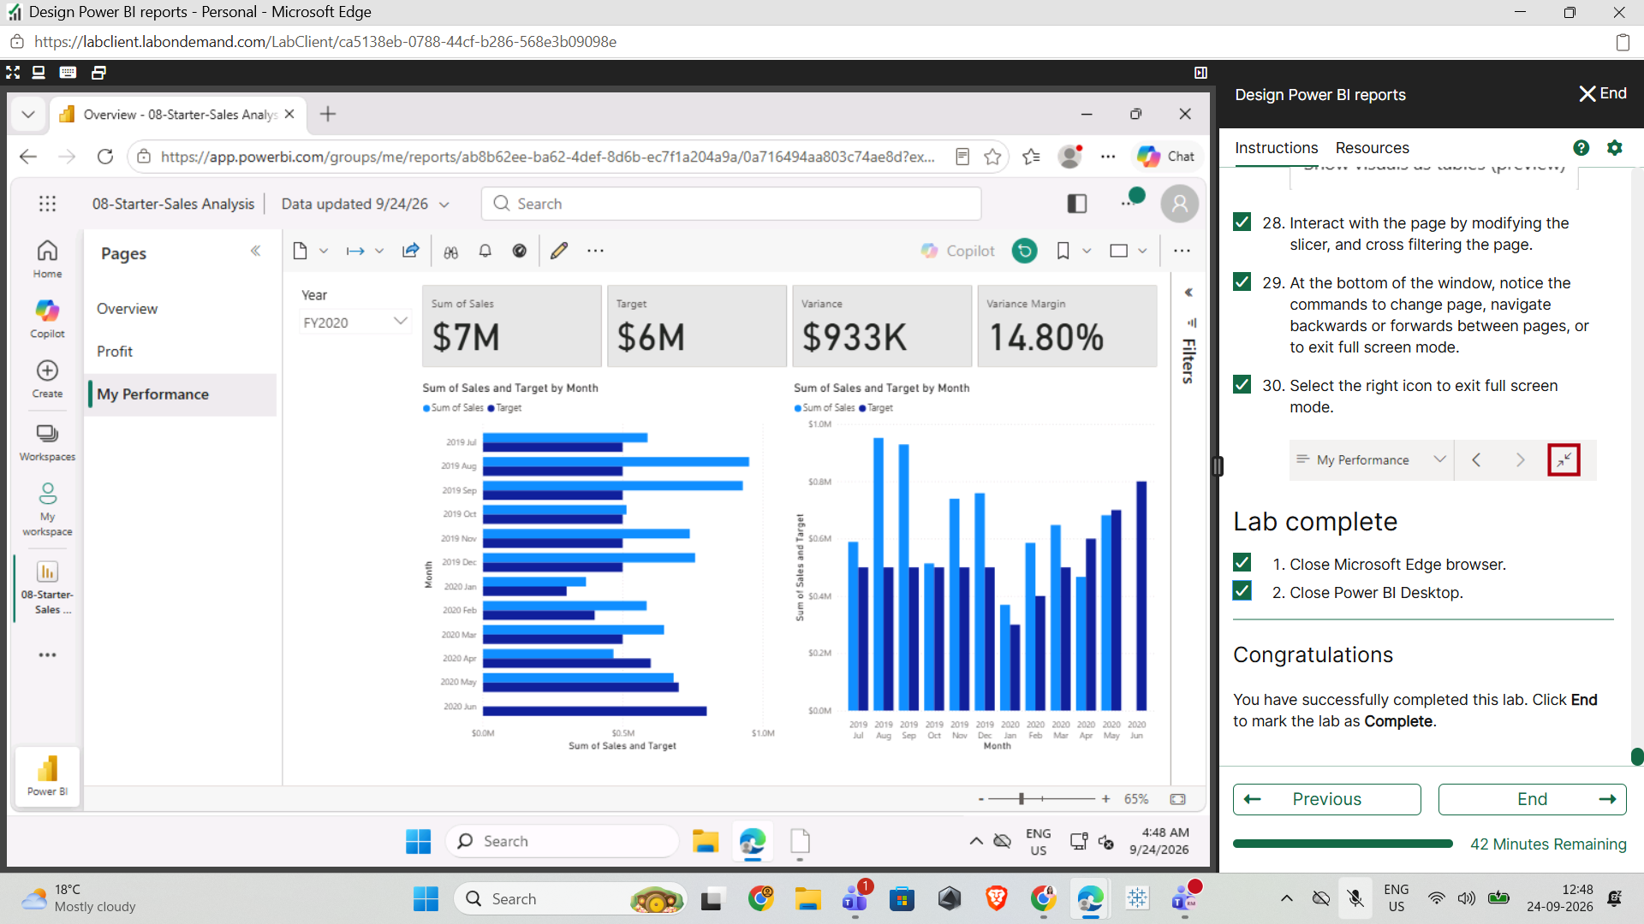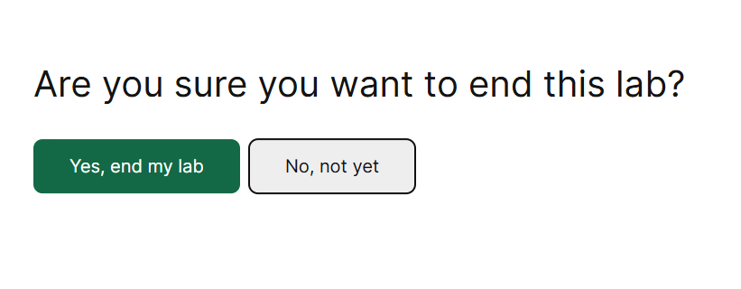

Day 4: Task 2

Please complete Create DAX calculations in semantic models on Skillable. Once complete, paste a print screen below and in the collaboration board.

- Visit https://leeptalent.learnondemand.net/
- Sing into your profile
- Go to PL-300T00-A Design and Manage Analytics Solutions Using Power BI
- Launch and complete Lab 4: Create DAX calculations in semantic models.

Paste your completed lab here | 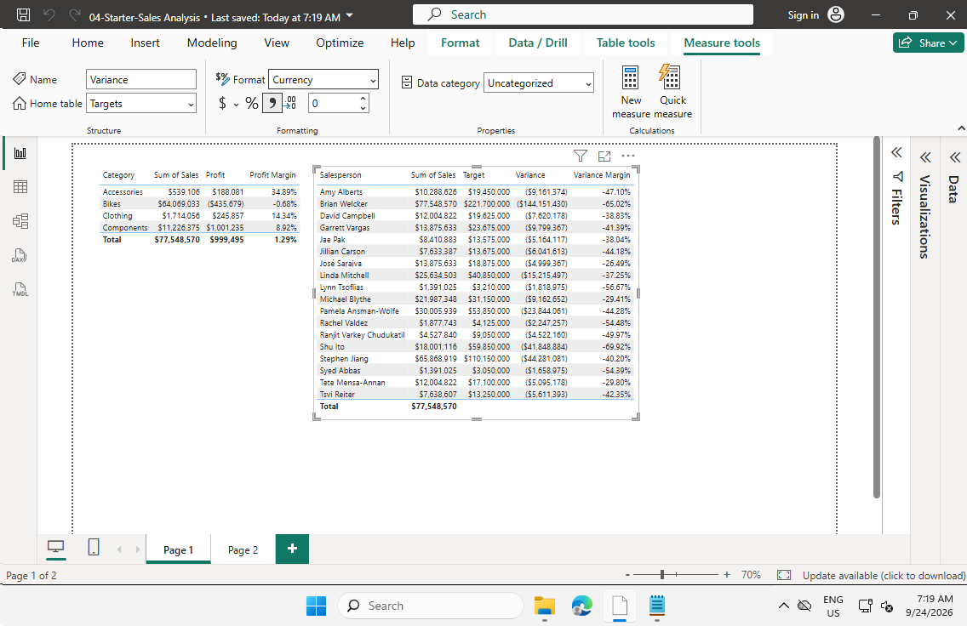

Day 4: Task 3

Please complete Configure a semantic model in Power BI. on Skillable. Once complete, paste a print screen below and in the collaboration board.

- Visit https://leeptalent.learnondemand.net/
- Sing into your profile
- Go to Lab PL-300T00-A Design and Manage Analytics Solutions Using Power BI
- Launch and complete Lab 3: Configure a semantic model in Power BI.

Paste your completed lab here | 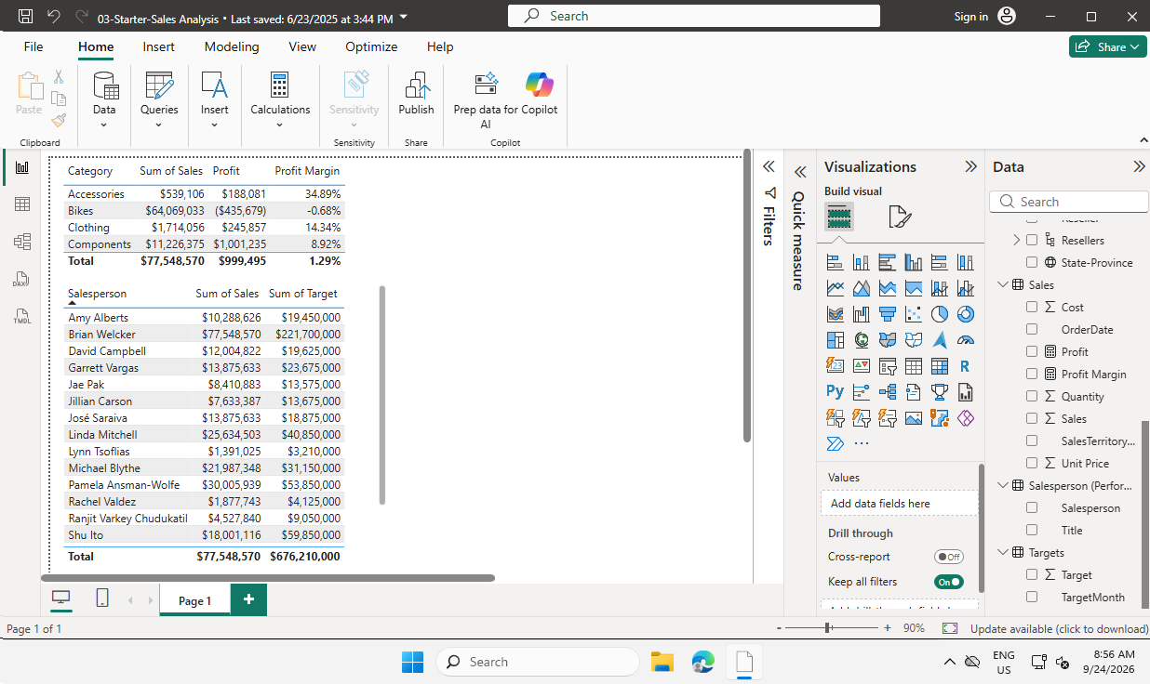

Course Notes

It is recommended to take notes from the course, use the space below to do so, or use the revision guide shared with the class:

Additional Resources to learn and Practice

- Introduction to Power BI - DataCamp Learn
- Power BI Cheat Sheet | DataCamp
- Data Modeling in Power BI - DataCamp Learn
- Introduction to DAX in Power BI - DataCamp Learn
- Data Visualization in Power BI - DataCamp Learn
- PL 300 Course on MS Learn. Course PL-300T00-A: Design and manage analytics solutions using Power BI - Training | Microsoft Learn This is an intermediate course.

END OF WORKBOOK

Please check through your work thoroughly before submitting and update the table of contents if required.

Please send your completed work booklet to your trainer.

